Lesson 6, Part I:
Building GUIs with JavaFX

Wholeness of the Lesson

JavaFX is a UI library in Java that allows developers to create user interfaces that are rich in content and functionality. The ultimate provider of tools for the creation of beautiful and functional content in manifest existence is pure intelligence itself; all creativity arises from this field’s self-interacting dynamics.

Overview
  - Using JavaFX components (learn more from api docs at
http://docs.oracle.com/javafx/2/api/ )

  - Layout basics
  - Handling GUI events
  - Using CSS to style your app
  - Declarative UI building using FXML
  - Deployment
First Example - HelloWorld.java

public class HelloWorld extends Application {
public static void main(String[] args) {
launch(args);
}

@Override
public void start(Stage primaryStage) {
primaryStage.setTitle("Hello World!");
Button btn = new Button();
btn.setText("Say 'Hello World'");
btn.setOnAction(new EventHandler<ActionEvent>() {
@Override
public void handle(ActionEvent event) {
System.out.println("Hello World!");
}
});
StackPane root = new StackPane();
root.getChildren().add(btn);
primaryStage.setScene(new Scene(root, 300, 250));
primaryStage.show();
}
}

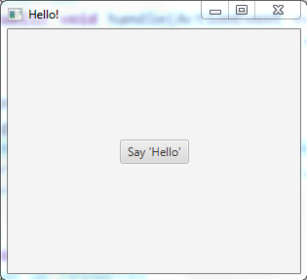

//Output
Hello World!

Points About the Hello World Example

Application class
The entry point for a JavaFX application is always a user-defined subclass of the abstract class javafx.application.Application class. The start() method starts up the application – it is the only abstract method of Application (and so must be implemented).

Stage Class

A JavaFX application defines the user interface container by means of a stage and a scene. The JavaFX Stage class is the top-level JavaFX container. The JavaFX Scene class is the container for all content. The demo above creates the stage and scene and makes the scene visible in a given pixel size.

StackPane Class

In JavaFX, the content of the scene is represented as a hierarchical scene graph of nodes. In this example, the root node is a StackPane object, which is a resizable layout node. (In a StackPane nodes are added along the z axis. Makes it easy to overlay text on a shape or image or to overlap common shapes to create a complex shape)

Components
The root node contains one child node, a button control with text, plus an event handler to print a message when the button is pressed.

Scene Graph
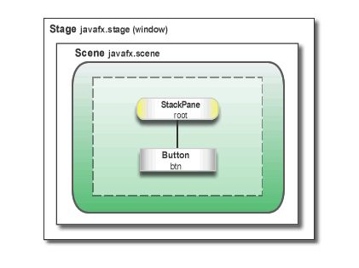
Main Point 1

For creating the look of a JavaFX application, two types of classes are primary: components and containers. A screen is created by setting the stage with the Stage and Scene container classes. And then the screen is populated with components, like buttons, textboxes, labels, and so on, starting at a root node and extending. Components and containers are analgous to the manifest and unmanifest fields of life; manifest existence, in the form of individual expressions, lives and moves within the unbounded container of pure existence.

Some General Points about JavaFX Apps

Main Method Is not Required
- The main() method is not required for JavaFX applications when the JAR file for the application is created with the JavaFX Packager tool.
  - The JavaFX Packager tool is a commandline tool used to compile, package and deploy a Java FX application (can be found here:
<path to Java> \Java\jdk1.8.0_45\bin\javafxpackager.exe)
  - Using the tool embeds the JavaFX Launcher in the output JAR file, so there is no need to call the Launcher from a main method.
- It is useful to include the main() method because
  - You can run JAR files that were created without the JavaFX Launcher (such as when using an IDE in which the JavaFX tools are not fully integrated, which is the case with Eclipse).
  - Swing applications that embed JavaFX code require the main() method.
- Read about the Packager tool here:
http://docs.oracle.com/javafx/2/deployment/packager.htm

The Life-cycle of a JavaFX Application
The entry point for JavaFX applications is the Application class. The JavaFX runtime does the following, in the following order, whenever an application is launched:
- Constructs an instance of the specified Application class
- Calls the init() method (for initializing; typical use: read commandline args See HelloWorld demo)
- Calls the start(javafx.stage.Stage) method
- Waits for the application to finish, which happens when either of the following occurs:
  - the application calls Platform.exit() (this can be done explicitly in code)
  - the last window has been closed (this is the default behavior, but it can be changed)
See HelloSecondWindow demo
- Calls the stop() method (typical use: clean up connections to resources)
NOTE:
- The start method is abstract and must be overridden.
- The init and stop methods have concrete implementations that do nothing by default

Two Threads
- Launcher thread. Application constructor and init method are called on this thread
- Application thread. JavaFX creates an application thread for running the application start method, processing input events, and running animation timelines.
- Creation of JavaFX Scene and Stage objects as well as modification of scene
graph operations to live objects (those objects already attached to a scene) must
be done on the JavaFX application thread.
NOTE: This means that an application must not construct a Scene or a Stage in either the constructor or in the init method.

Second Example - Creating a Form in JavaFX

In this example we build a login form – illustrates:
- basics of screen layout
- how to add controls to a layout pane
- how to create input events and handle them.

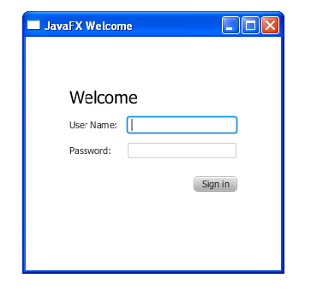

Sample Code
@Override
public void start(Stage primaryStage) {
primaryStage.setTitle("JavaFX Welcome");
GridPane grid = new GridPane();
grid.setAlignment(Pos.CENTER);
grid.setHgap(10);
grid.setVgap(10);
//top, right, bottom, left
grid.setPadding(new Insets(25, 25, 25, 25));

Text scenetitle = new Text("Welcome");
scenetitle.setFont(Font.font("Tahoma", FontWeight.NORMAL, 20));
grid.add(scenetitle, 0, 0, 2, 1);

Label userName = new Label("User Name:");
grid.add(userName, 0, 1);

TextField userTextField = new TextField();
grid.add(userTextField, 1, 1);

Label pw = new Label("Password:");
grid.add(pw, 0, 2);

PasswordField pwBox = new PasswordField();
grid.add(pwBox, 1, 2);

Button btn = new Button("Sign in");
HBox hbBtn = new HBox(10);
hbBtn.setAlignment(Pos.BOTTOM_RIGHT);
hbBtn.getChildren().add(btn);
grid.add(hbBtn, 1, 4);

final Text actiontarget = new Text();
grid.add(actiontarget, 1, 6);

btn.setOnAction(new EventHandler<ActionEvent>() {

@Override
public void handle(ActionEvent e) {
actiontarget.setFill(Color.FIREBRICK);
actiontarget.setText("Sign in button pressed");
}
});

Scene scene = new Scene(grid, 300, 275);
primaryStage.setScene(scene);
primaryStage.show();
}

Create a GridPane Layout

GridPane is a layout node that works like an HTML table. You can place controls in any cell in the grid, and you can make controls span cells as needed.
GridPane grid = new GridPane();
grid.setAlignment(Pos.CENTER);
grid.setHgap(10);
grid.setVgap(10);
grid.setPadding(new Insets(25, 25, 25, 25));
Scene scene = new Scene(grid, 300, 275);
primaryStage.setScene(scene);

- alignment property changes the default position of the grid from the top left of the scene to the center.
- gap properties control the spacing between the rows and columns in the grid
- padding property controls the space around the edges of the grid pane
- insets occur in this order: top, right, bottom, and left. (In this example, there are 25 pixels of padding on each side).
NOTES:
- When the scene is created, the grid pane is the root node – this is usual approach when using layout containers
- As the window is resized, the nodes within the grid pane are resized according to their layout constraints.
- The padding properties ensure there is a padding around the grid pane when you make the window smaller.
- Code sets the scene width and height to 300 by 275. If you do not set the scene dimensions, the scene defaults to the minimum size needed to display its contents.

Add Text, Labels, and Text Fields

Sample Code:

Text scenetitle = new Text("Welcome");
scenetitle.setFont(Font.font("Tahoma", FontWeight.NORMAL, 20)); //better to set these values in a stylesheet
grid.add(scenetitle, 0, 0, 2, 1);

Label userName = new Label("User Name:");
grid.add(userName, 0, 1);

TextField userTextField = new TextField();
grid.add(userTextField, 1, 1);

Label pw = new Label("Password:");
grid.add(pw, 0, 2);

PasswordField pwBox = new PasswordField();
grid.add(pwBox, 1, 2);

- TextFields are constructed to have width of 12 pixels by default. The preferred width can be modified using setPrefColumnCount(numCols), or setPrefWidth(pixels), but layout may override preferences.

- How positions in the grid are specified: (column num, row num):
(0, 0) | (1, 0) | (2, 0)
(0, 1) | (1, 1) | (2, 1)

- The last two arguments of the grid.add() method set the column span to 2 and the row span to 1.

Debugging

For debugging, GridPane allows you to display the grid lines. Do this here by adding this line of code
grid.setGridLinesVisible(true)
right after adding the password field.
When code is run, you see this:
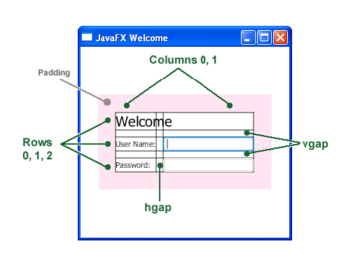

Positioning a Component in GridPane with HBox

Sample code:

Button btn = new Button("Sign in");
HBox hbBtn = new HBox(10);
hbBtn.setAlignment(Pos.BOTTOM_RIGHT);
hbBtn.getChildren().add(btn);
grid.add(hbBtn, 1, 4);

- The HBox layout pane is created to allow you to place the button in a special place.
- HBox constructor accepts a spacing parameter (spacing between components). In this case, alignment is set to Pos.BOTTOM_RIGHT
- If other components are added to an HBox, they are laid out from left to right.

Other Layouts

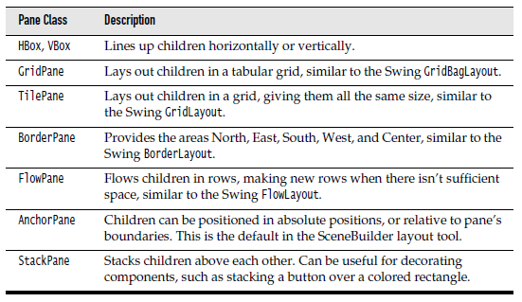

Main Point 2

In JavaFX, components are arranged in a container through the use of layouts that organize components in different ways. The most convenient layout is GridPane, which allows you to organize components in a table format, and suffices for most layout needs. For special layout requirements, JavaFX provides half a dozen other layout types. Likewise, all of manifest life is conducted by a vast network of natural laws.

Event Handling

Sample code:

final Text actiontarget = new Text();
grid.add(actiontarget, 1, 6);

btn.setOnAction(new EventHandler<ActionEvent>() {

@Override
public void handle(ActionEvent e) {
actiontarget.setFill(Color.FIREBRICK);
actiontarget.setText("Sign-in button pressed");
}
});

Add a Text control for displaying the message, as shown below.

The setOnAction() method is used to register an event handler that sets the value of actiontarget to “Sign-in button pressed” when the user presses the button. The color of the actiontarget object is set to firebrick red.

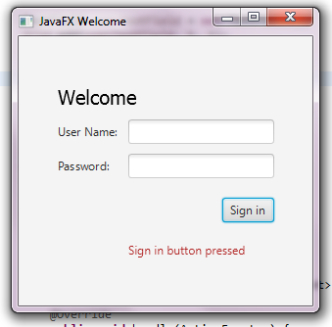

More Examples – Other Techniques

Demo lesson6.lecture.javafx.secondwindow illustrates:

- Setting background color of the root
- Creating and using a status bar
- Setting up a ComboBox and responding to user selections with a ChangeListener
- ToggleButton for toggling between states in response to button clicks
- Creating multiple Stages and how communication between them is accomplished.

Demo lesson6.lecture.javafx.tables illustrates the use of menus and tables in JavaFX.
- The Start class creates a MenuBar, adds two Menus, and adds MenuItems to the first Menu.
- The ShoppingCartWindow creates a TableView. TableViews are created one column at a time. In this example, all cells have been made read-only, but with more work, cells can be editable. A TableView requires some Java class to provide the data that it will read and present. In this example, ShoppingCart provides the necessary data. During TableView construction, the field names from ShoppingCart are specified and each will represent one of the TableView columns. After the ShoppingCartWindow has been created, data for the table can be set using the setData method that has been provided. This method accepts a List of ShoppingCarts; each ShoppingCart in the list will be displayed as a row in the table.

Main Point 3

A GUI becomes responsive to user interaction (for example, button clicks and mouse clicks) through the event-handling model of JavaFX, in which event sources are associated with EventHandler classes, whose handle method is called (and is passed an Event object) whenever a relevant action occurs. To make use of this event-handling model, the developer defines a handler class, implements the handle method, and, when defining an event source (like a button), registers the handler class with this event source component. The “observer” pattern that is used in JavaFX mirrors the fact that in creation, the influence of every action is felt everywhere; existence is a field of infinite correlation; every behavior is “listented to” throughout creation.
Fancy Forms with JavaFX CSS

For this example, we are going to add a Cascading Style Sheet (CSS) to the JavaFX application as shown below. See lesson6.lecture.javafx.logincss

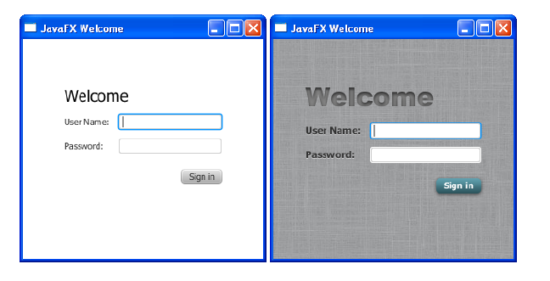

Add CSS Styling to the Login Class

Steps:
- Create a new CSS file and save it in the same directory as Login.java.
- Specify location of the CSS file using the following code:
Scene scene = new Scene(grid, 300, 275);
primaryStage.setScene(scene);
scene.getStylesheets().add(
getClass().getResource("Login.css").toExternalForm());
primaryStage.show();

- Reference:

http://docs.oracle.com/javafx/2/css_tutorial/jfxpub-css_tutorial.htm
Detailed reference:

http://docs.oracle.com/cd/E17802_01/javafx/javafx/1.3/docs/api/javafx.scene/doc-files/cssref.html
Other ways to access a CSS file are discussed here:
https://blog.idrsolutions.com/2014/04/use-external-css-files-javafx/

Add a Background Image

.root {
-fx-background-image: url("background.jpg");
}

The background image is applied to the .root style, which means it is applied to the
root node of the Scene instance.

The style definition consists of
- the name of the property: -fx-background-image, and
- the value for the property: url("background.jpg").

Style the Labels

When you specify .label in your stylesheet, the values that are set affect all Labels in the form.
.label {
-fx-font-size: 12px;
-fx-font-weight: bold;
-fx-text-fill: #333333;
-fx-effect: dropshadow(
gaussian , rgba(255,255,255,0.5) , 0,0,0,1 );
}

This example
- sets the font size and weight
- sets text-fill to gray
- applies a drop shadow (the purpose of the drop shadow is to add contrast between the dark gray text and the light gray background).
- rgba is RGB + alpha. Alpha (values in range 0..1) specifies opacity
- dropshadow parameters can be looked up at http://docs.oracle.com/javafx/2/api/javafx/scene/doc-files/cssref.html

Style Text

Apply css styling to the two Text objects: scenetitle (includes the text Welcome) and actiontarget (“signed in” message at bottom).

Steps:

1. Remove the Java coding of styles (we will replace them with CSS) Remove the following lines of code that define the inline styles currently set for the text objects:

scenetitle.setFont(Font.font(“Tahoma”, FontWeight.NORMAL, 20));
actiontarget.setFill(Color.FIREBRICK);

2. Create an ID for each text node by using the setID() method of the Node class:

scenetitle.setId("welcome-text");
actiontarget.setId("actiontarget");

- In the Login.css file, define the style properties for the welcome-text and actiontarget IDs. For the style name, use the ID preceded by a number sign (#), as shown below –

#welcome-text {
-fx-font-size: 32px;
-fx-font-family: "Arial Black";
-fx-fill: #818181;
-fx-effect: innershadow( three-pass-box , rgba(0,0,0,0.7) , 6, 0.0 , 0 , 2 );
}

#actiontarget {
-fx-fill: FIREBRICK;
-fx-font-weight: bold;
-fx-effect: dropshadow( gaussian , rgba(255,255,255,0.5) , 0,0,0,1 );
}

NOTES: The text fill color for welcome-text is set to a dark gray color (#818181) and an inner shadow effect is applied, creating an embossing effect.

Style the Button

We style the button so that it changes style when the user hovers the mouse over it.

Steps:
- Create the style for the initial state of the button by adding the code below. This code uses the .button style class selector, such that if you add a button to the form at a later date, then the new button will also use this style.

.button {
-fx-text-fill: white;
-fx-font-family: "Arial Narrow";
-fx-font-weight: bold;
-fx-background-color: linear-gradient(#61a2b1, #2A5058);
-fx-effect: dropshadow( three-pass-box , rgba(0,0,0,0.6) ,
5, 0.0 , 0 , 1 );
}

- Create a slightly different look for when the user hovers the mouse over the button. You do this with the hover pseudo-class. A pseudo-class includes the selector for the class and the name for the state separated by a colon (:), as shown below -

.button:hover {
-fx-background-color: linear-gradient(#2A5058, #61a2b1);
}

Using FXML to Create a User Interface
- Mark-up Language. FXML is a mark-up language based on XML that is used to design and lay out JavaFX components, and attach event handlers; FXML markup is rendered by the JVM into a fully functioning UI.
- Declarative programming. FXML makes it possible to develop UI code in a declarative style, using XML commands to declare what is needed rather than writing the Java code that accomplishes the goal. This flexibility makes it possible to develop FXML code using a designer tool, which supports drag-and-drop layout of components and event-handling. The tool that accomplishes this is called SceneBuilder.
- Topics for FXML:
  - We give a quick review of XML, including an example of how it is read and used in a Java program
  - We re-build the small Login app using FXML (without the use of SceneBuilider) showing FXML markup syntax and how it is used by JavaFX code.
  - In Part II, we show how to work with FXML documents using Scene Builder.

Review of XML
- What is XML?
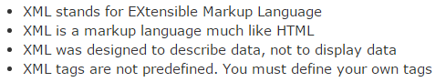
- Sample:
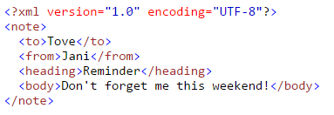
First line is a declaration. The tag <note> is called the root.
- General Tree Structure:
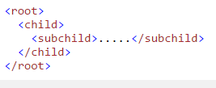
- Points about XML
- All XML elements must have a closing tag
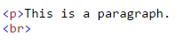 | 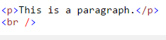
illegal | correct
- XML tags are case-sensitive : <Note> is different from <note>
- Tags must be properly nested (often overlooked in older HTML documents)
 | 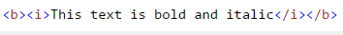
illegal | correct
- XML documents must have a root element
- XML attributes must be quoted (often overlooked in HTML)
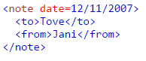 | 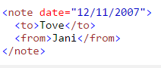
illegal | correct
- Processing instructions are tags beginning and ending with ? that are typically used to give instructions to an application that processes the XML. Same syntax as the XML declaration, but for a different purpose.
An example found in HTML documents to declare a CSS stylesheet is the following:
- Parsing XML. There have been two main approaches for parsing XML files, both of which are supported in Java
- Scanning each character starting at the beginning of the file (SAX parsing)
- Treat elements and attributes of the XML document as nodes in a tree and traverse the tree to get information about the XML content (DOM parsing)
- DOM = Document Object Model. JavaScript uses DOM to navigate the elements of an HTML page. We illustrate how DOM is used to read in XML files (next slide), and we give a simple XML example of DOM processing in lesson6.lecture.javafx.domprocessing
DOM Example

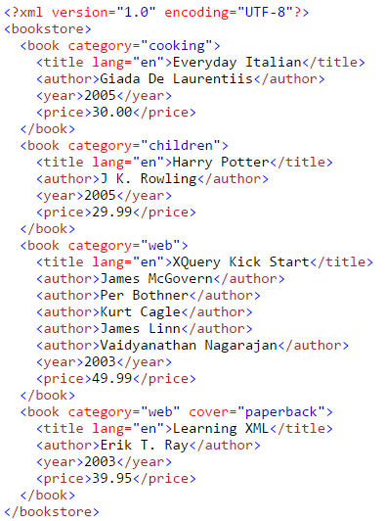
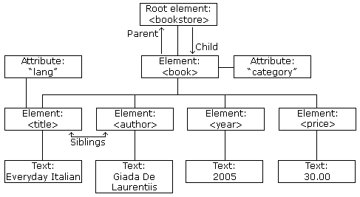
DOM Tree
See XML demo code in lesson6.lecture.javafx.domprocessing
FXML Basics
When building a UI using FXML, there are two types of documents to create: the FXML file(s) and the controlling Java file(s). Here are shells of these for the Login app:
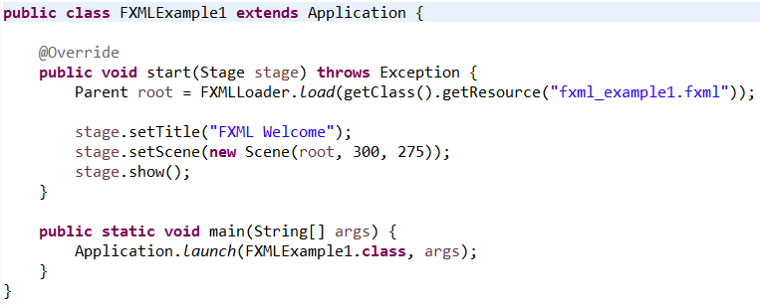
Java Code
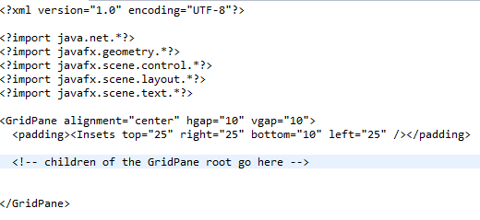
FXML Code
- XML processing instructions are used to specify Java imports
- The root of the FXML document is the root of the Scene that is being built.
- Nesting in the FXML document parallels the nesting that is done in building JavaFX components (as we did in building the Login app).
- The Java code shows how to access the values specified in the FXML document. After obtaining the root, further JavaFX changes can be made directly in Java.
FXML Example 1: Component Layout
The sample code in
lesson6.lecture.javafx.fxmlexample.FXMLExample1
shows how components are laid out using an FXML document
FXML Example 2: Connect Java and FXML Code
The demo
lesson6.lecture.javafx.fxmlexample.FXMLExample2
shows how to link between Java code and the FXML code, using id fields (similar to the approach in JavaScript).
Note:
- The id fields are specified as attributes of component elements in the FXML document.
<Text id="actiontarget" GridPane.columnIndex="1" GridPane.rowIndex="6" />
- You reference components having id tags in the FXML document using Java syntax like the following:
Text target = (Text)root.lookup("#actiontarget");
- In this approach, event-handling can be done inside the Java code by retrieving (by id) an event-generating component (like a Button) and attaching an event-handler (see the demo).

FXML Example 3: Event Handling
The demo
lesson6.lecture.javafx.fxmlexample.FXMLExample3

shows how to handle events in a better way, by injecting event-generating components into a Controller class, responsible for event-handling code.

Notes:

- You inject components into a controller class using the @FXML annotation.
- Components that need to be referenced in the controller must have “fx:id” tags instead of simply “id” tags.
- You reference an event handler within the FXML document with code like this:
<Button text="Sign In" onAction="#handleSubmitButtonAction" />
When the button is clicked, the JVM will look for a method handleSubmitButtonAction in the controller class, and will execute this method.
- To tell the JVM about the class that you will use as controller, you include an fx:controller attribute in the root, like this:
fx:controller=
"lesson6.lecture.javafx.fxmlexample.FXMLExampleController"
- To tell the JVM about the “fx” namespace, you also include in the root the attribute xmlns:fx, like the following:
xmlns:fx=http://javafx.com/fxml
- Using a Controller class to be responsible for event-handlers is an application of the Mediator design pattern (discussed in Software Engineering) and supports the principle “separation of concerns” – separating the static UI layout code from the dynamic event-handling code.
FXML Example 4:
Referencing CSS Styles in the FXML Document
The demo
lesson6.lecture.javafx.fxmlexample.FXMLExample4

adds lines to the FXML document to handle CSS styling.

Deploying Your First JavaFX Application

JavaFX applications can be run in several ways:

- Launch as a desktop application from a JAR file or self-contained application launcher
- Launch from the command line using the Java launcher
- Launch by clicking a link in the browser to download an application
- View in a web page when opened

For this course, we are going to do it in the first way.

Here are instructions for doing that:

From your Eclipse workspace:

- right click your JavaFX application
- create a special Run Configuration – example: HelloWorldToJar
(Duplicate existing Run Configuration and rename it) , then Close
- right click on the application again and select export…select Java folder
- Runnable JAR file (Next)
- Select launch configuration you just created
- choose Export Destination
Now, run the JAR file you just created by double-clicking the file.
Lesson 6, Part II:
Building GUIs with SceneBuilder

- Make sure you have a version of Eclipse that supports SceneBuilder. We have used efxclipse, which is Luna with several SceneBuilder plugins preloaded
http://efxclipse.bestsolution.at/install.html#all-in-one
- Download and install SceneBuilder. Instructions are in the setup folder for the course
- Go through a demo to build the Login app using SceneBuilder
- CONNECTING THE PARTS OF KNOWLEDGE
WITH THE WHOLENESS OF KNOWLEDGE

The self-referral dynamics
arising from the reflexive association of container classes

- In JavaFX, components are placed and arranged in container classes for attractive display.
- In JavaFX, certain container classes (like HBox) are also considered to be components; this makes it possible to place and arrange container classes inside other container classes. These self-referral dyanmics support a much broader range of possibilities in the design of GUIs.


- Transcendental Consciousness: TC is the self-referral field of all possibilities.
- Wholeness moving within Itself: In Unity Consciousness, all activity is appreciated as the self-referral dynamics of one's own Self.

